User Guide for College/Institute Affiliation

Contents
College Admin 3
1.1.1 Registration 4
1.1.2 Institute 9
1.1.3 Increase No. Of Seats 13
1.1.4 Application For New Course (Already Existing In University) 14
1.1.5 Application For New Course (Not Existing In University) 15
1.1.6 Renewal Of Affiliation (For Existing course) 17
1.1.7 Payment Detail 18

College Admin
The College Admin can send application for new course addition, existing course upgrade or seat increase.
- Log in as College. Type user name and password.
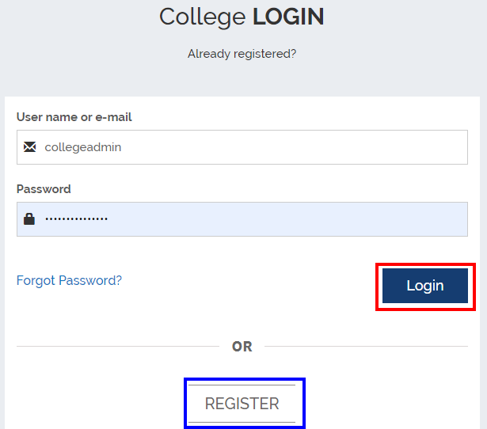
- Click LOGIN.
- Once you log in as College, the Registration page opens up.
- You will be prompted to answer whether your college is registered or not. Click Yes or No.

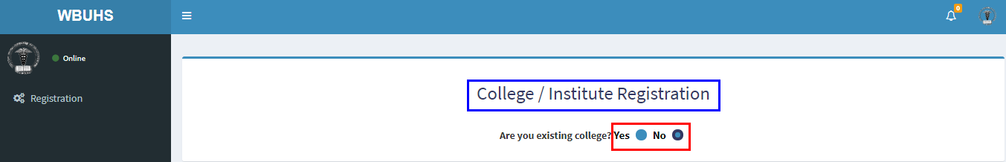

Registration

Existing College
If you click Yes, the College/Institute registration form opens up, as shown below. 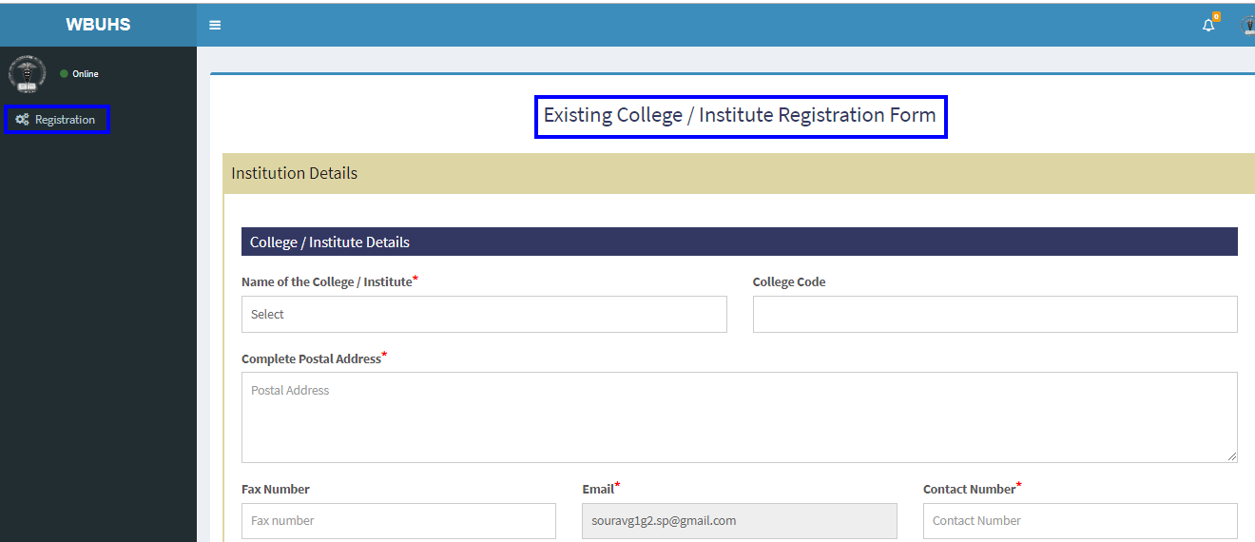
- Select the college/institute name from the drop-down list. As soon you select a college, the relevant college code (of the existing college) is generated.
- Fill up the form.

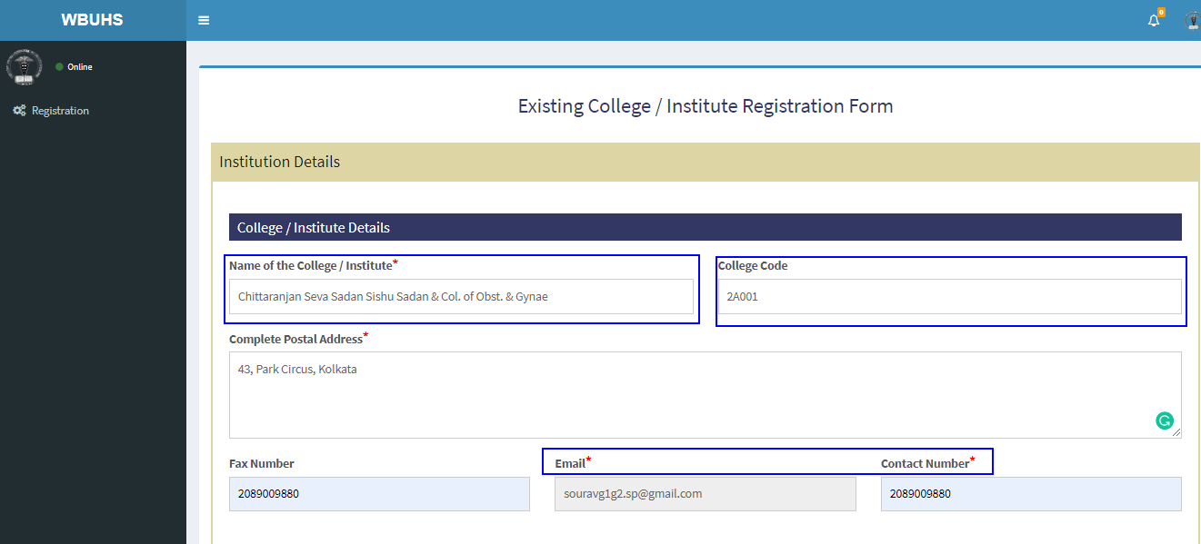

All mandatory fields have been marked with a red asterisk.
The mandatory fields are:
- Name of the College / Institute
- Complete Postal Address
- Email
- Contact Number
- Work Postal Address
- Name of Principal / Director
- Work Postal Address
- Email
- Contact Number
- Contact Person Details
- Name of the Contact Person for the Institution
- Email
- Contact Number

- Next, fill up the course details, by choosing the relevant course names from the tree-structure as shown in the screen shot below.
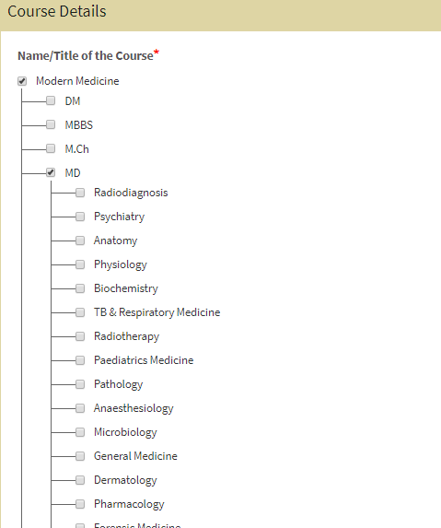

- Add details for intake capacity.
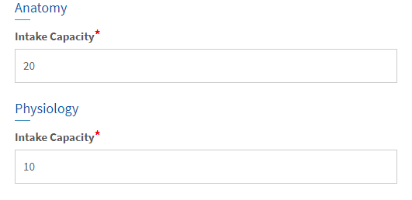
- Once done, click Submit.
- The course is added, as shown by the success message on the dashboard. Please refer to the following screen shot.
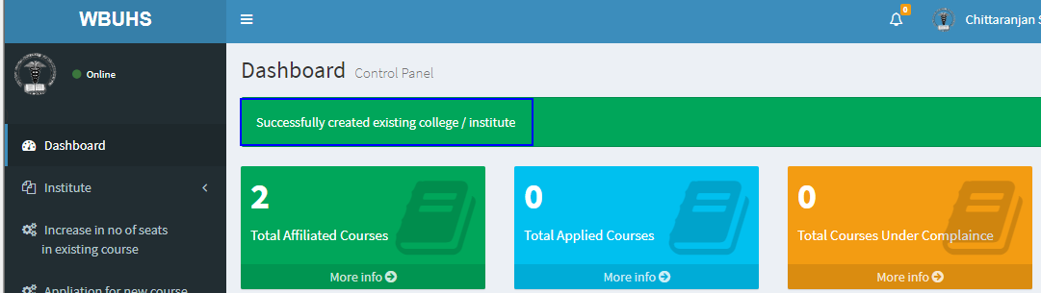

New Registration
If your college is not registered, click No on the Registration page.
Then the following registration page opens up.
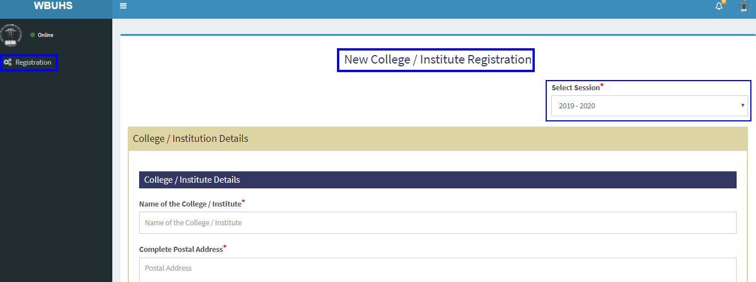
- Type your college name in the space provided for Name of the College/Institution and select the academic session from the drop-down menu, as shown in the screen shot above.
- Fill up all the fields. All mandatory fields have been marked with a red asterisk. Follow the same steps as in Existing College in the earlier section.
The mandatory fields are:
- Name of the College / Institute
- Complete Postal Address
- Email
- Contact Number
- Work Postal Address
- Name of Principal / Director
- Work Postal Address
- Email
- Contact Number
- Contact Person Details
- Name of the Contact Person for the Institution
- Email
- Contact Number

- In addition, you have to fill up details for:
- Infrastructure Details: The College/Institution admin has to furnish details like: Location(s) where the new course is/are proposed to be conducted or whether the applicant Institute has permanent ownership of the building or acquired it on lease, and covered area and vacant space allotted/dedicated/available for this proposed new course
- Details of Class Room:
  - No of class rooms available for this course
  - Room capacity
  - Floor space of each class room
  - Total floor area
- Details of Laboratory:
  - No of Laboratory room(s) available for running this course
  - Room capacity
  - Floor space of each laboratory room
  - Total floor area of the laboratory room(s)
- Library:
  - Total space (in sq ft or sq meter)
  - Total capacity (.i.e. how many students can sit and study in the library)
  - Whether the Library has Space allotted for students of this new course

  - Total No of Books
  - Lending section
  - Reference section
  - Total No of Journal & Periodicals subscribed
    - National
    - International
  - Facilities available
- Computers:
  - Whether the applicant Institute has hospital of its own or has agreement with other hospital for training and research purpose
  - Own Agreement with other hospital
- Hospital:
  - Name of the Hospital
  - Number of beds
  - Average occupancy / day
  - Average number of patients in OPD / day
  - Whether Hostel accommodation of students are available
  - Whether separate hostel accommodations of students of this new course are available
- Other amenities:
  - Common room for students
  - Canteen
  - Open space for recreation
  - Vehicle stand
  - Gent’s Toilet
  - Ladies Toilet
  - Details of Management of the College/Institute
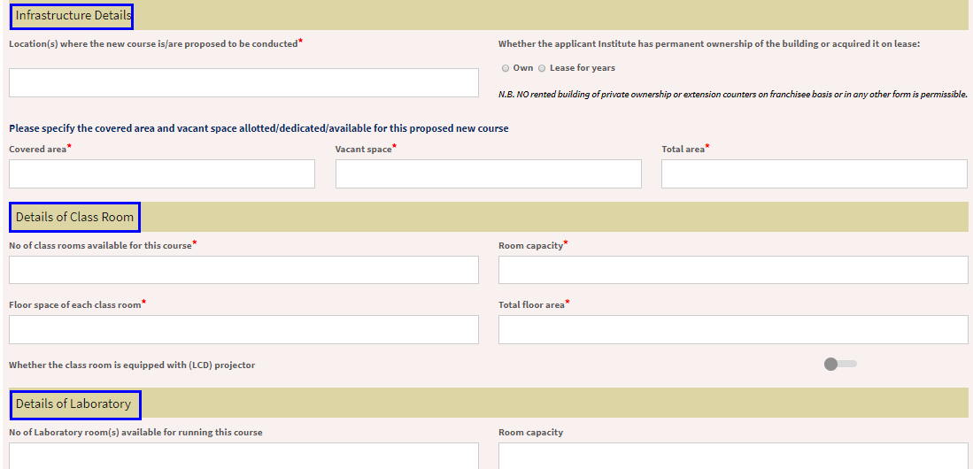

- Payment Mode: The College/Institution admin has to specify the mode of payment.
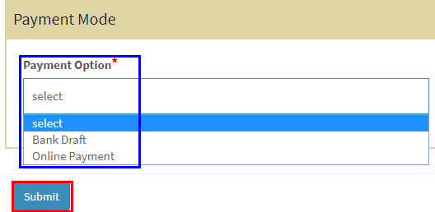
- Click Submit.
- Your college is successfully added.

Institute
After you log in as a college admin user, the dashboard opens up as shown in the screen shot below.
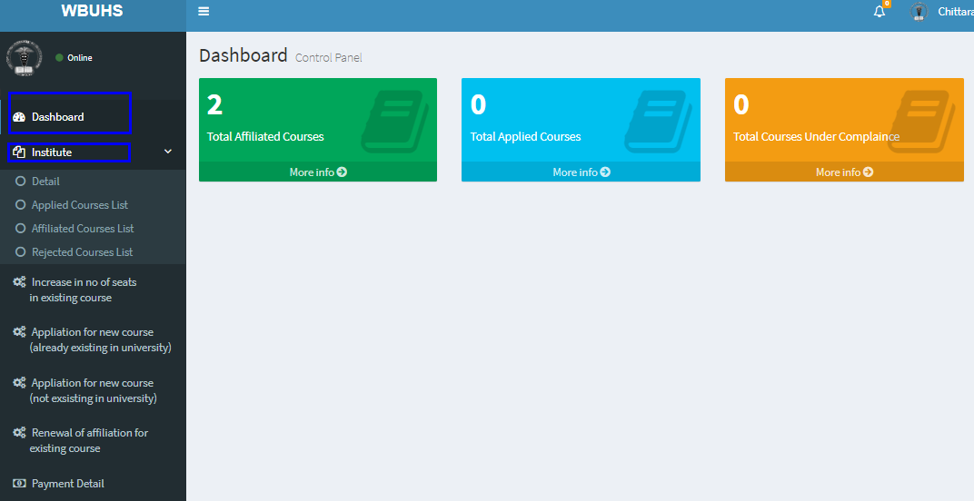

Details
As you click the Details tab, the respective page opens up, showing the following details:
- College/institution details
- Principal/Director details
- Contact person details
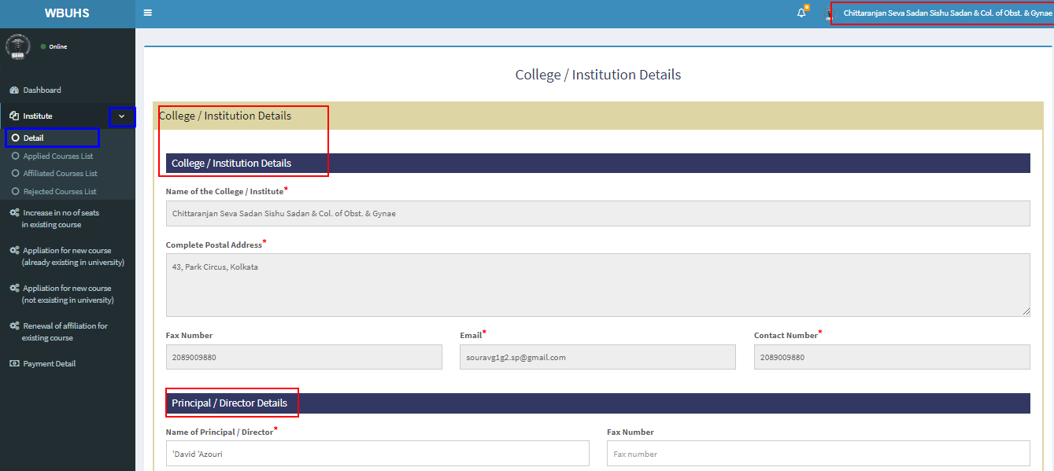

As you click the Details tab, the sub menu shows the following:
- Applied colleges list
- Affiliated colleges list
- Rejected colleges list

Applied Colleges List
When you click the first menu item Applied Colleges List opens on the right pane showing the following details of an applied college:
- New course applied detail
- Existing course increase detail

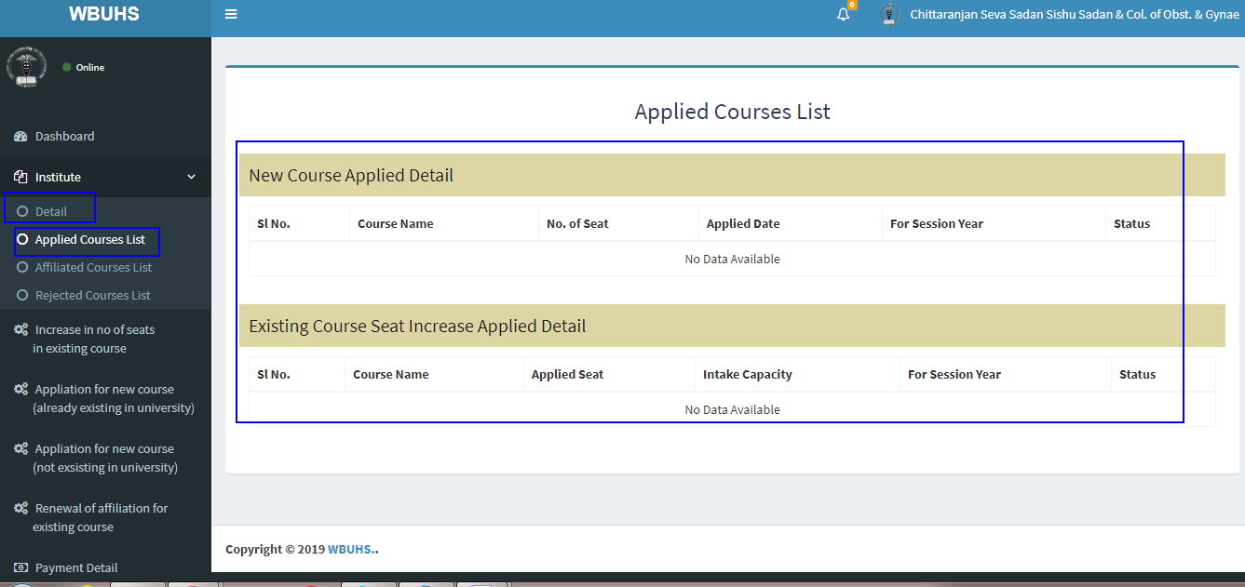

Affiliated Courses List

On the Affiliated Courses List tab on the left pane, the respective page opens up, as highlighted in the screen shot below.
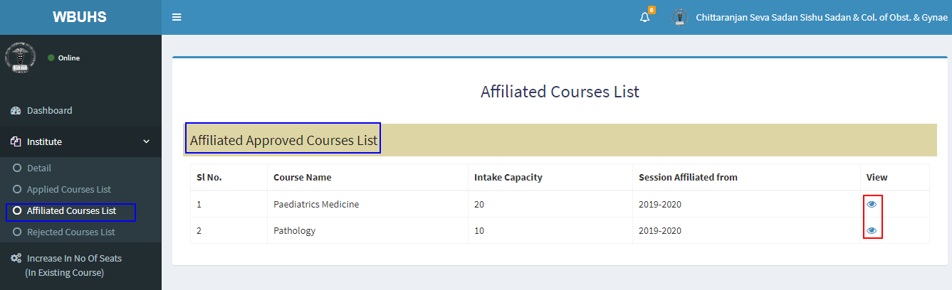
On clicking the view button, you can see details of the affiliated course, as shown below.

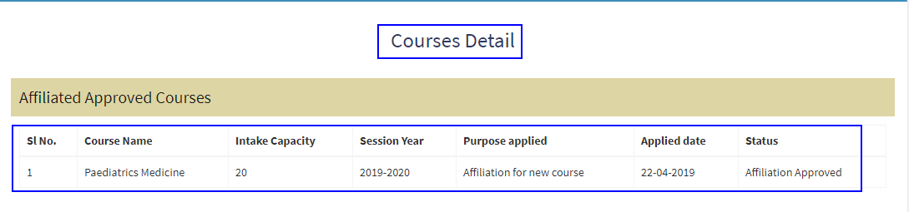

Rejected Courses List

On clicking the Rejected Courses List, the respective page opens on the right pane, as shown in the screen shot below.
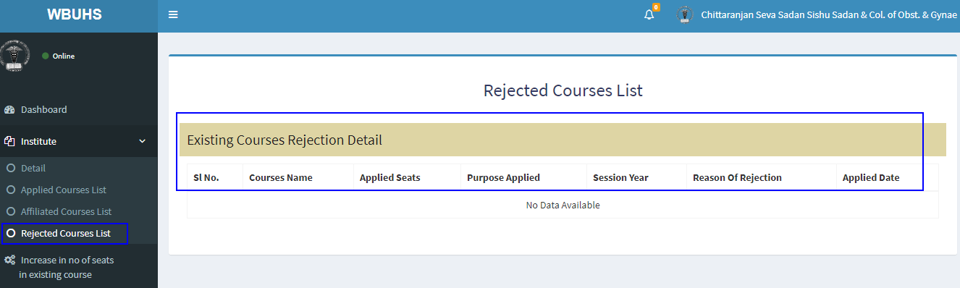

Increase No. Of Seats
If you click Increase In No. Of Seats (In Existing Course), the respective page opens up in the right pane.
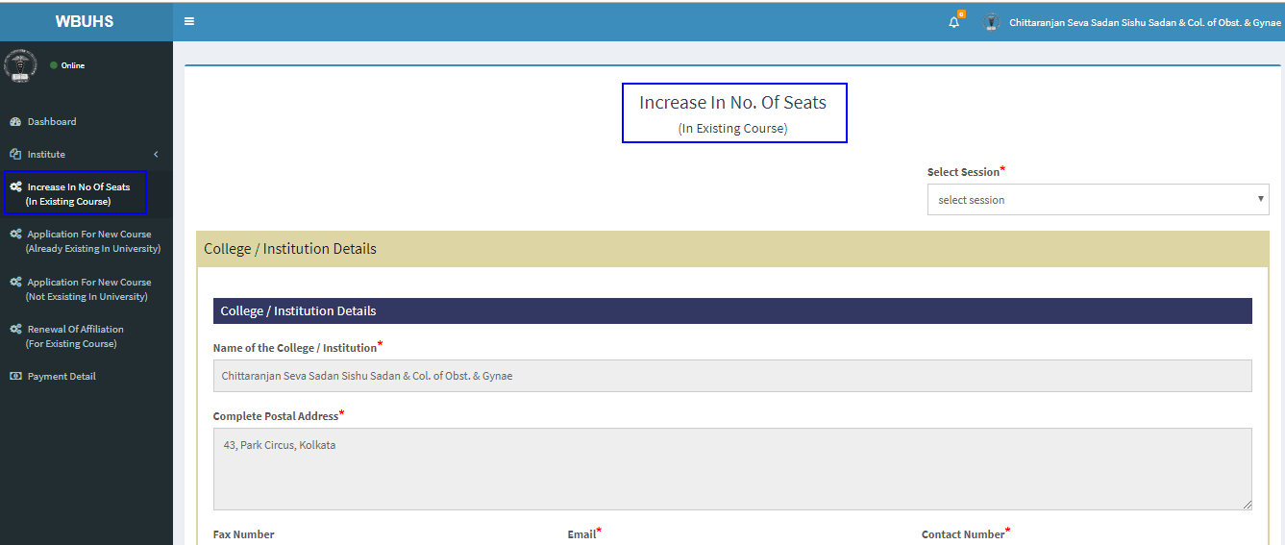
You can view the following details:
- College / Institution Details
  - College / Institution Details
  - Principal / Director Details
  - Contact Person Details
- Courses List
- Payment Mode

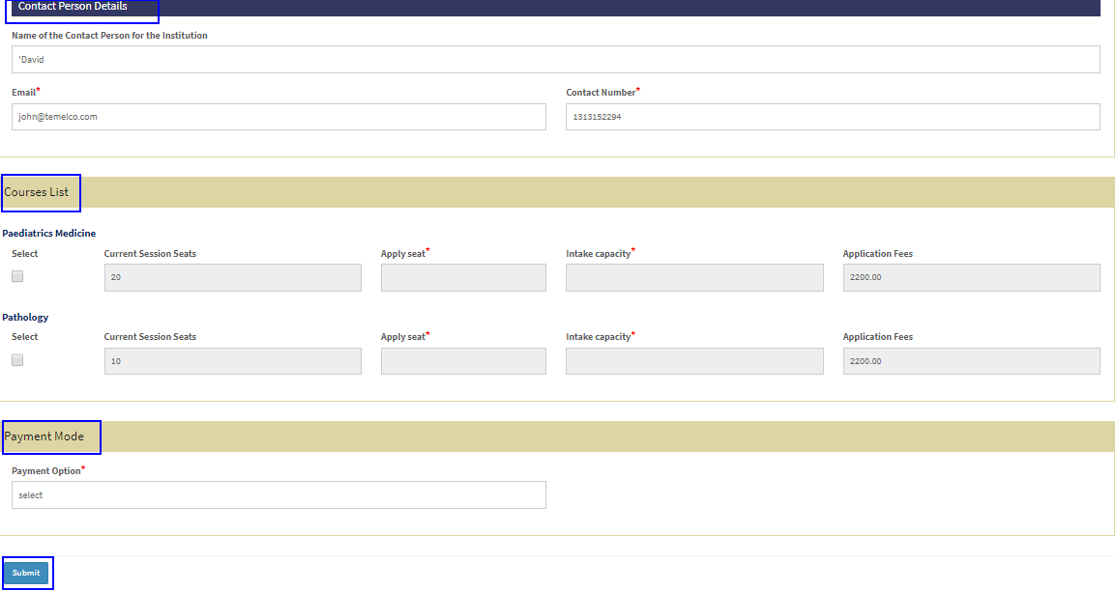

Application For New Course (Already Existing In University)

If you click Application For New Course (Already Existing In University) from the left pane, the respective page opens up, as shown in the screen shot above.
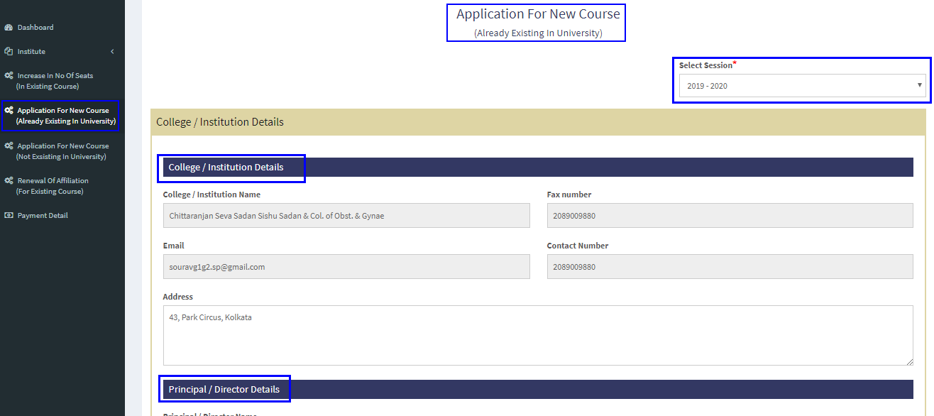

You can view details like:
- College / Institution Details
  - College / Institution Details
  - Principal / Director Details
- Information of the Contact Person
- Course Details
- Payment Mode

Application For New Course (Not Existing In University)
On clicking the Application For New Course (Not Existing In University) from the left pane, the respective page opens up as shown below.

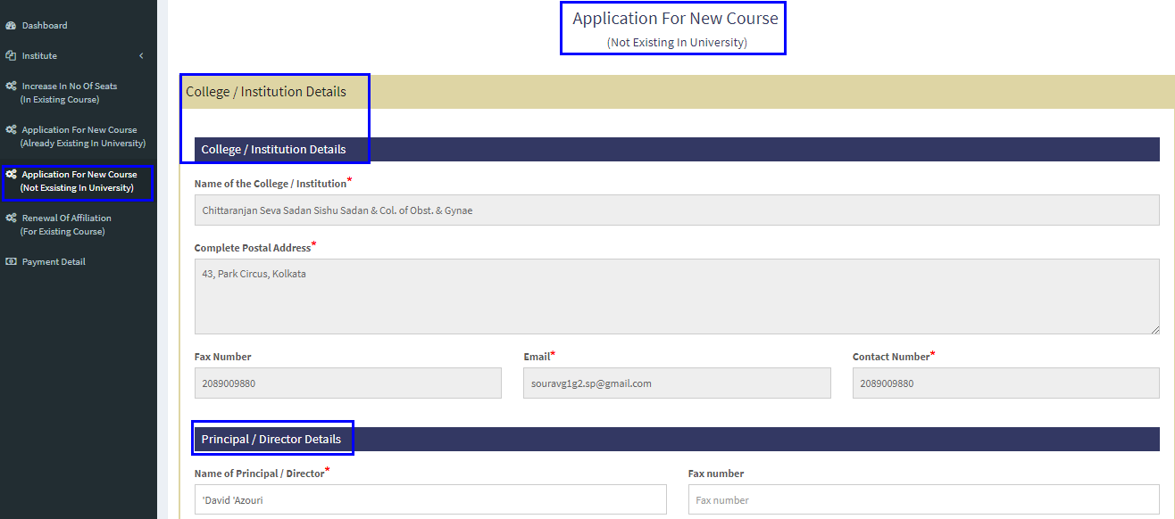

You can view the following details:
- College / Institution Details
  - College / Institution Details
  - Principal / Director Details
- Information of the Contact Person
- Course Details

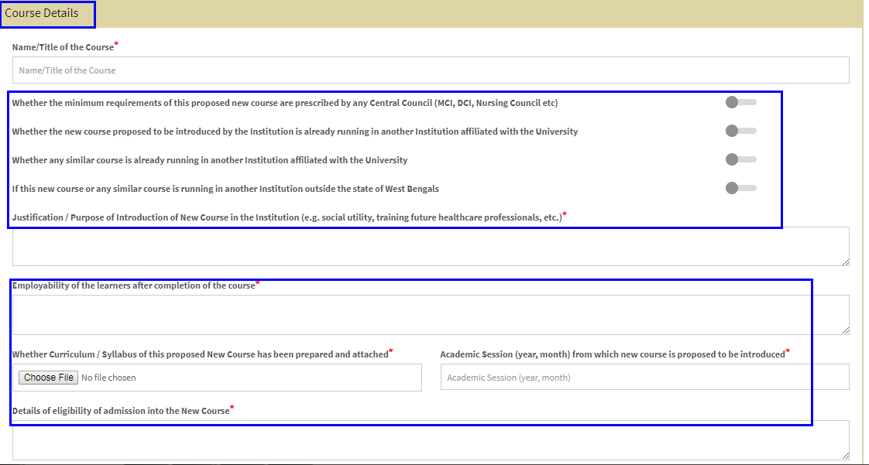

- Infrastructure details

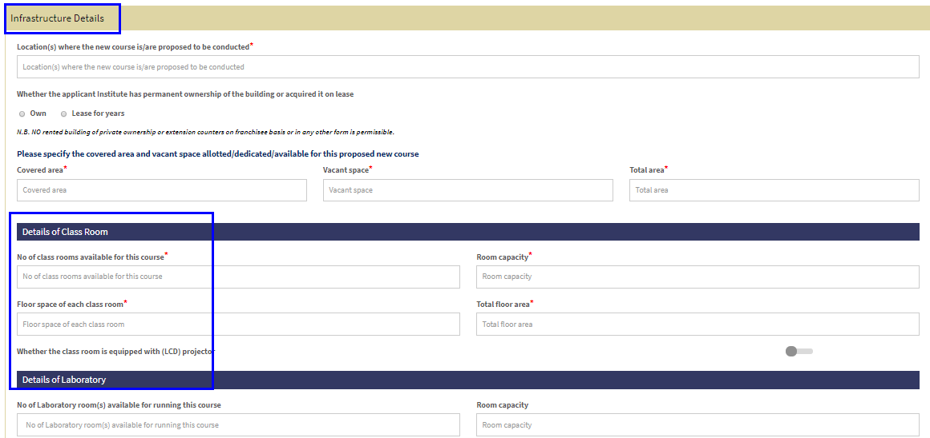

- Payment mode

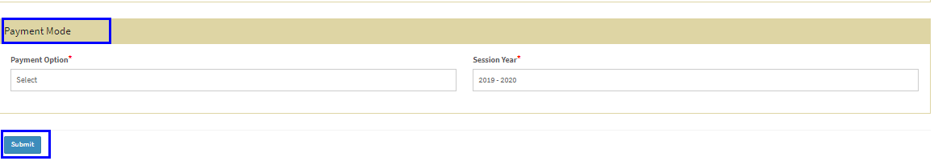

Renewal Of Affiliation (For Existing course)

On clicking the Renewal Of Affiliation (For Existing course) from the left pane, you will be taken to the respective page, as shown in the screen shot below.
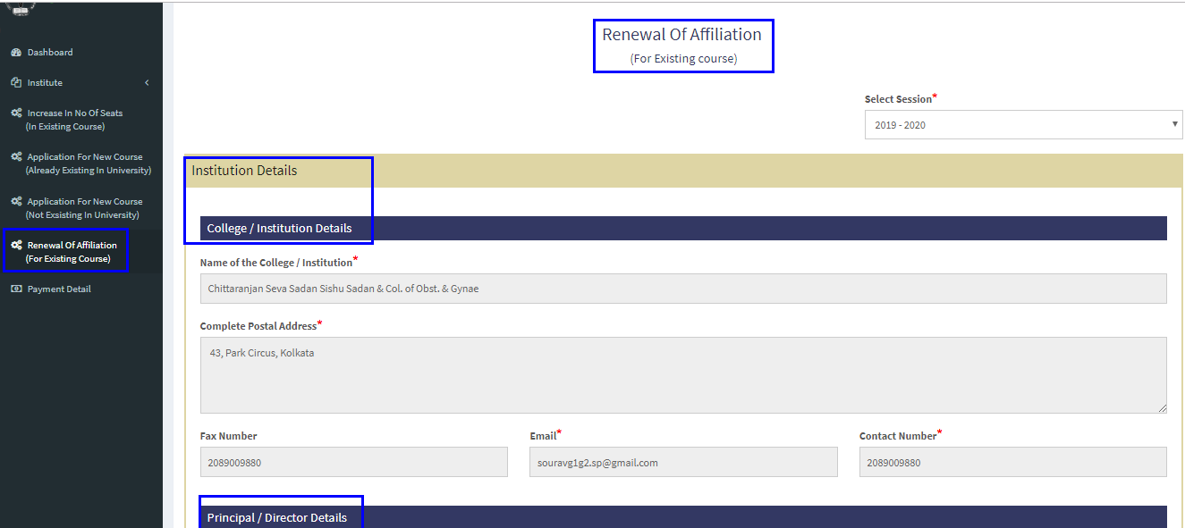

You can view details like:
- College / Institution Details
  - College / Institution Details
  - Principal / Director Details
- Information of the Contact Person
- Course Details
- Payment Mode

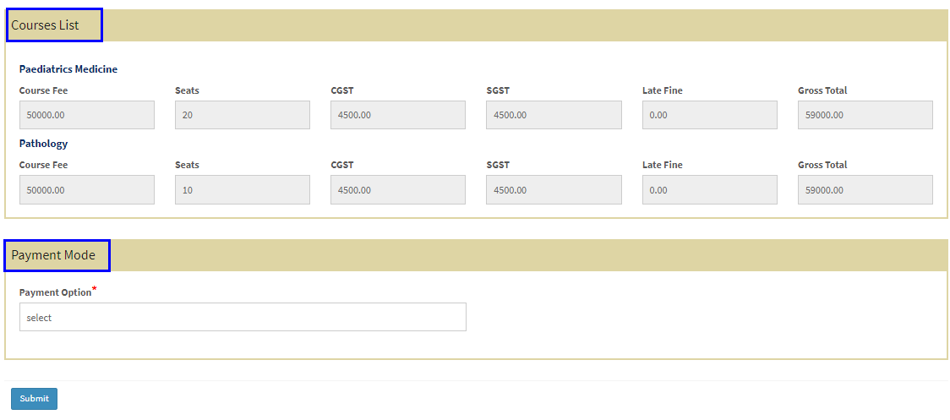

Payment Detail
By clicking the Payment Detail tab on the left pane, the respective page will open up.
